**Name ___________________________**

**Unit 8 Practice Test**

**Circles**

**Part A – Circles & the Pythagorean Theorem**

1. Find the area of the shaded region.



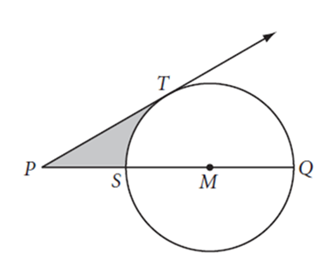

1. Find the area of the shaded region.

*SQRE* is a square and *SQ* = 6m.



**Part B – Equations of Circles**

1. The equation of a circle is ${4x}^{2}+{4y}^{2}-16x+24y-36=0$. Identify the center and radius of the circle. Show your work to justify your answer.
2. Write the equation of a circle in standard form whose diameter has endpoints (4, -1) and (-6, 7). Rewrite the equation in general form. Show all of your work!

Standard Form: _______________________ General Form: _______________________

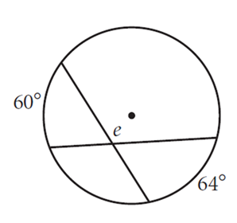**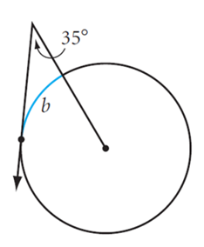Part C – Solving For Parts of a Circle**

1.  **6.** 

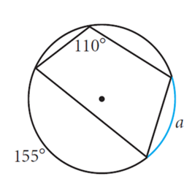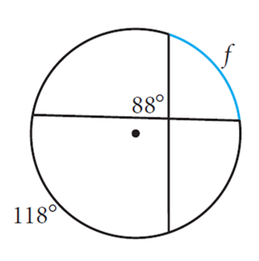

**7**.  **8.** 

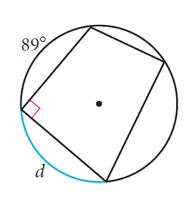

1. 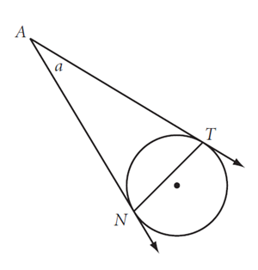 **10**. 



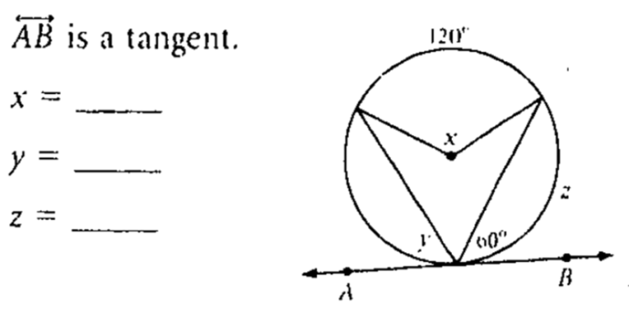

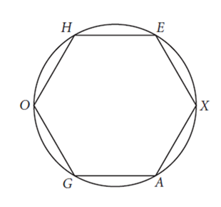**11.** **12.** HEXAGO is a regular hexagon inscribed in a circle.



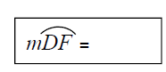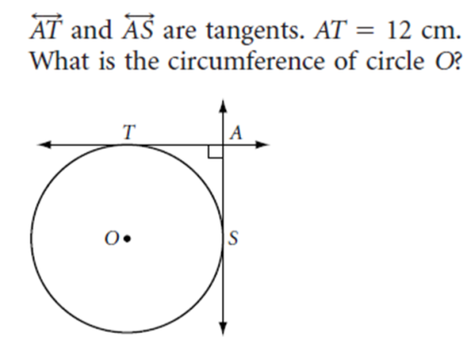

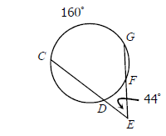 **13. 14.**

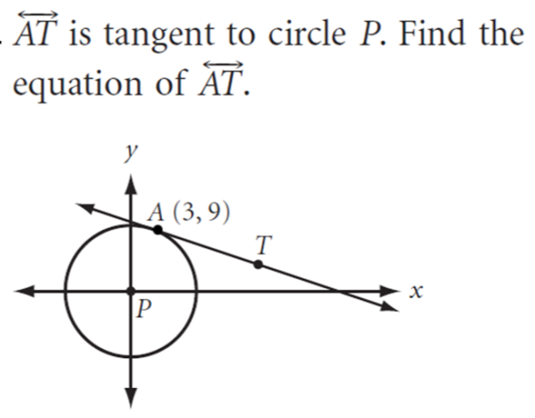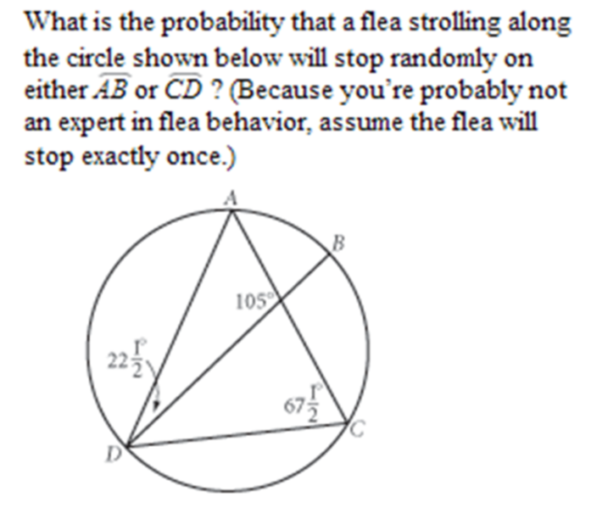 **15. 16.**

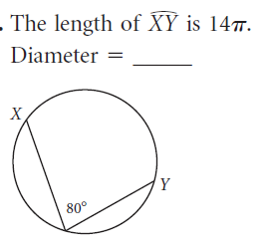

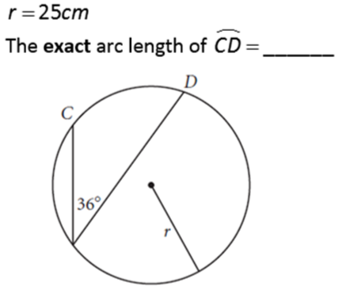 **17. 18.**

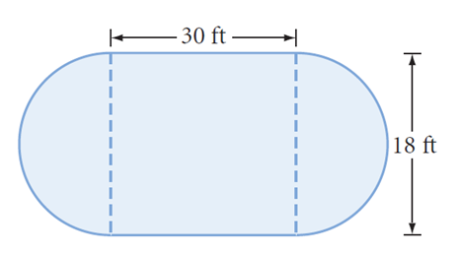**19.** Pool contractor Peter Tileson needs to determine the number of 1-inch tiles to put around the edge of a pool. The pool is a rectangle with two semicircular ends as shown. How many tiles will be needed?

1.  Points A, B and C lie on the circumference of the circle centered at O. If $m∠OAB=50°$ and $m∠BCO=60°$, what is the measure of $∠AOC$? **Hint: You will need to draw something in on the diagram**

**Part D – Areas of Shaded Regions**

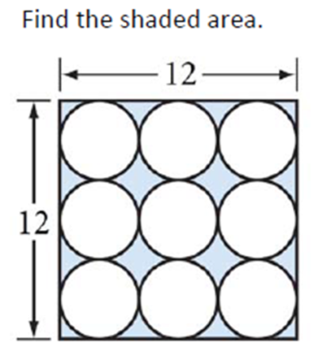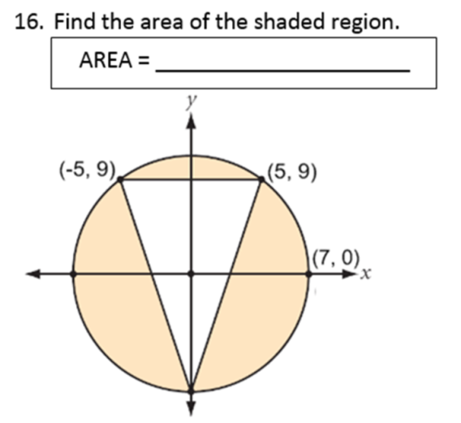

1. **22.**

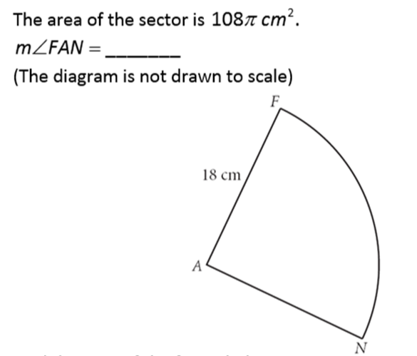

1. 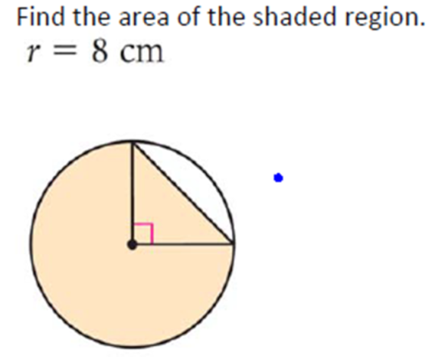 **24.**



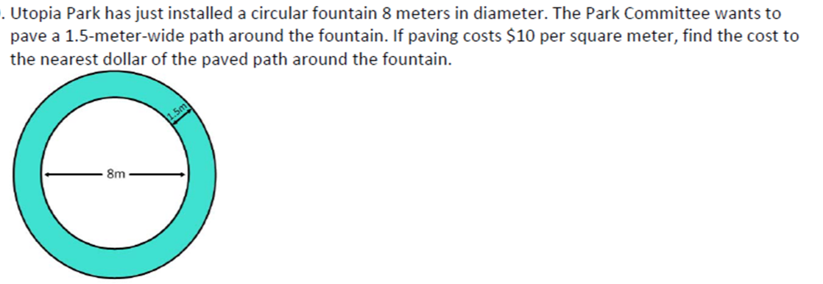**25.**

**Part E – Solving Equations**

**26.** Set up an equation and **solve by factoring**. **27.** Set up an equation and **solve by completing the**

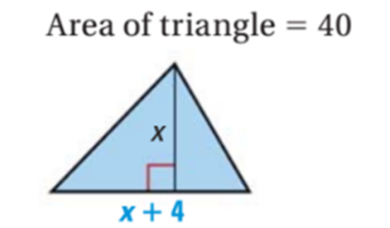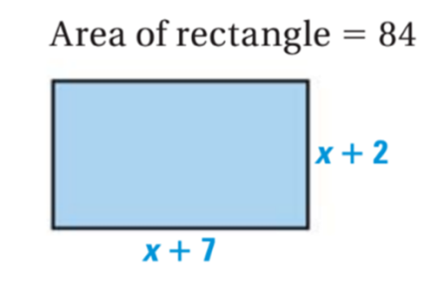 **square.**